AWS Hands-on Lab: Cross-Region VPC Peering — Hyderabad ↔ Mumbai
Objective
In this lab, you will:
- Create a custom VPC in the Hyderabad region.
- Create a subnet in the Hyderabad VPC.
- Create an Internet Gateway and attach it to the Hyderabad VPC.
- Create a Route Table and associate it with the Hyderabad subnet.
- Launch an EC2 instance in the Hyderabad VPC.
- Create another VPC in the Mumbai region.
- Create a subnet in the Mumbai VPC.
- Create an Internet Gateway and attach it to the Mumbai VPC.
- Create a Route Table and associate it with the Mumbai subnet.
- Launch an EC2 instance in the Mumbai VPC.
- Create a VPC Peering connection between Hyderabad and Mumbai.
- Accept the peering request in Mumbai.
- Add the required routes for communication between the VPCs.
- Configure Security Groups for SSH and ICMP testing.
- Test communication between the EC2 instances.

What is VPC Peering?
VPC Peering is a network connection between two VPCs that allows resources in those VPCs to communicate with each other.
The VPCs can be:
- In the same AWS Region.
- In different AWS Regions.
- In the same AWS account.
- In different AWS accounts.
In this lab, we are connecting:
Hyderabad VPC
|
| VPC Peering
|
↓
Mumbai VPC
The main purpose of VPC Peering is to allow communication between resources in two VPCs.

Architecture
AWS Cloud
|
+----------------+----------------+
| |
Hyderabad Region Mumbai Region
ap-south-2 ap-south-1
| |
↓ ↓
HYD VPC Mumbai VPC
10.0.0.0/16 30.0.0.0/16
| |
↓ ↓
HYD Subnet Mumbai Subnet
10.0.0.0/24 30.0.2.0/24
| |
↓ ↓
HYD EC2 Mumbai EC2
| |
+-------- VPC Peering ----------+
pcx-xxxx

Resource Naming Convention
AWS Resource | Hyderabad | Mumbai
VPC | StudentName-HYD-VPC | StudentName-Mumbai-VPC
Subnet | StudentName-HYD-Subnet | StudentName-Mumbai-Subnet
Internet Gateway | StudentName-HYD-IGW | StudentName-Mumbai-IGW
Route Table | StudentName-HYD-RT | StudentName-Mumbai-RT
Security Group | StudentName-HYD-SG | StudentName-Mumbai-SG
EC2 | StudentName-HYD-EC2 | StudentName-Mumbai-EC2
VPC Peering | StudentName-HYD-Mumbai-Peering | Same connection

Step 1 — Create Hyderabad VPC
Change the AWS Region to:
Asia Pacific (Hyderabad)
ap-south-2
Navigate to:
AWS Console
→ VPC
→ Your VPCs
→ Create VPC
Configure:
Setting | Value
Resources to create | VPC only
Name | StudentName-HYD-VPC
IPv4 CIDR | 10.0.0.0/16
IPv6 CIDR | None
Tenancy | Default
Click:
Create VPC
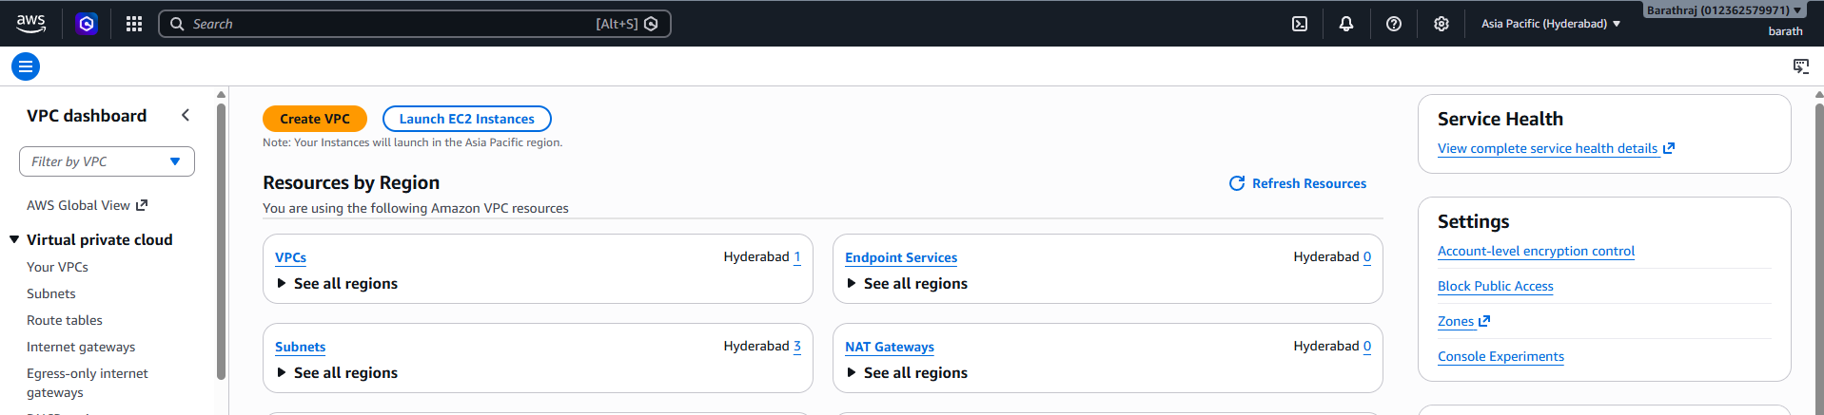
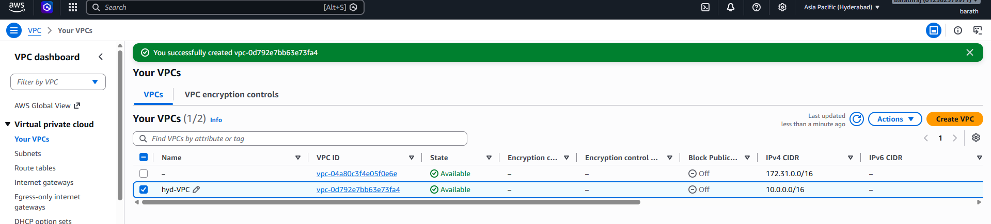

Step 2 — Create Hyderabad Subnet
Navigate to:
VPC
→ Subnets
→ Create subnet
Configure:
Setting | Value
VPC | StudentName-HYD-VPC
Subnet name | StudentName-HYD-Subnet
Availability Zone | ap-south-2a
IPv4 CIDR | 10.0.0.0/24
Click:
Create subnet
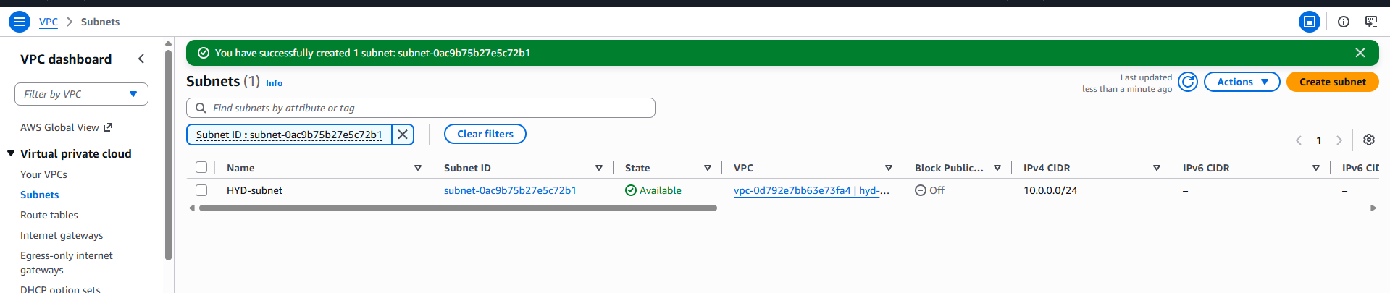

Step 3 — Create Hyderabad Internet Gateway
Navigate to:
VPC
→ Internet Gateways
→ Create Internet Gateway
Configure:
Name:
StudentName-HYD-IGW
Click:
Create Internet Gateway
Attach it to the VPC:
Actions
→ Attach to VPC
→ StudentName-HYD-VPC
The Internet Gateway is now attached to the Hyderabad VPC.
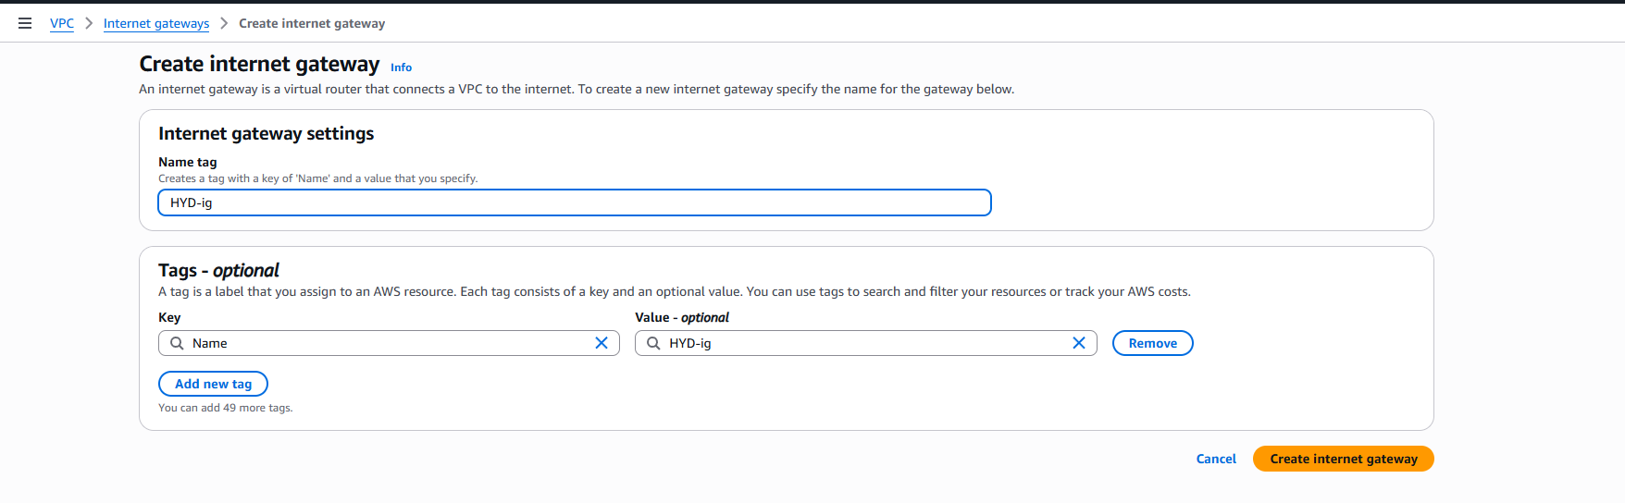
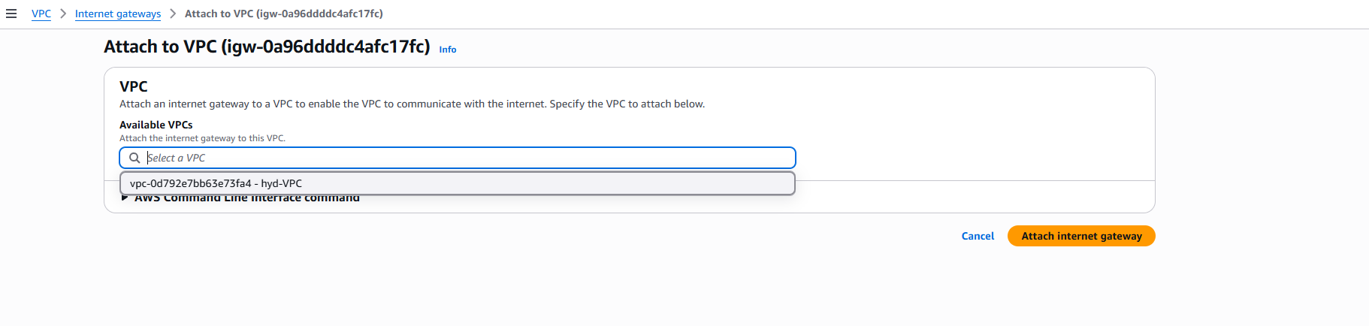

Step 4 — Create Hyderabad Route Table
Navigate to:
VPC
→ Route Tables
→ Create Route Table
Configure:
Setting | Value
Name | StudentName-HYD-RT
VPC | StudentName-HYD-VPC
Click:
Create route table
Add Internet Route
Open the route table:
Routes
→ Edit routes
→ Add route
Configure:
Destination | Target
0.0.0.0/0 | Internet Gateway
Select:
StudentName-HYD-IGW
Save the route.
Associate the Route Table with the Subnet
Go to:
Subnet associations
→ Edit subnet associations
Select:
StudentName-HYD-Subnet
Save the association.
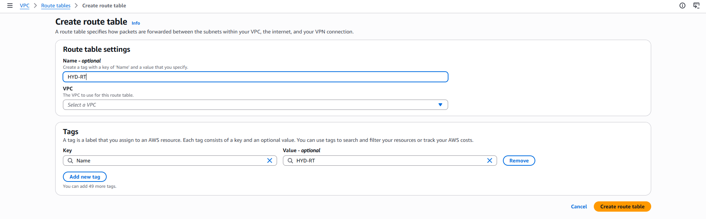
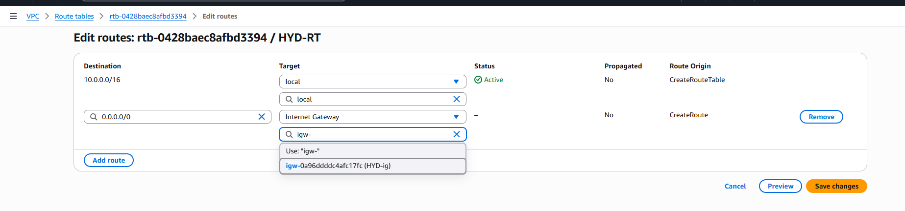
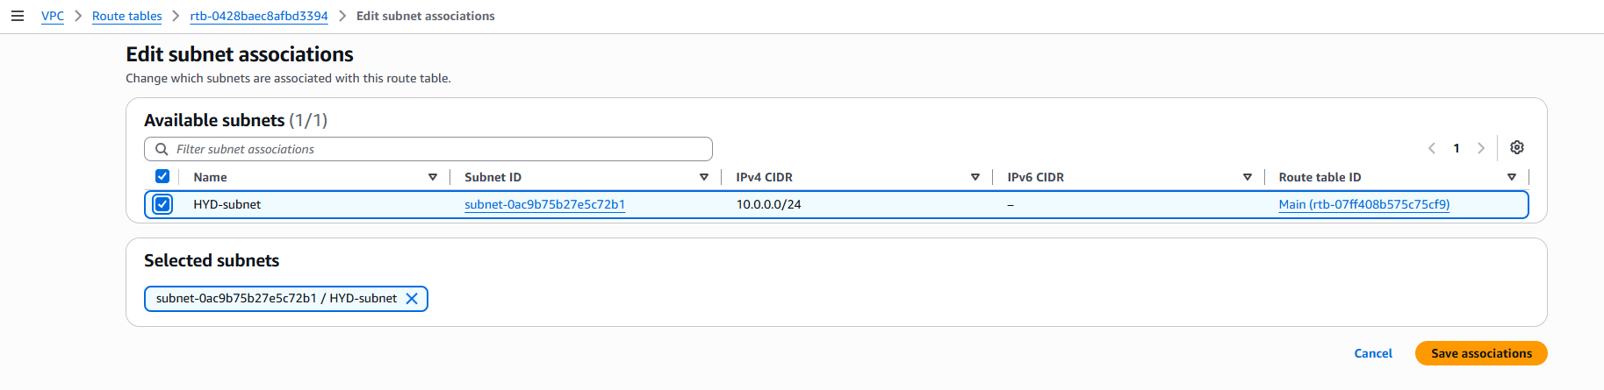

Step 5 — Create Mumbai VPC
Change the AWS Region to:
Asia Pacific (Mumbai)
ap-south-1
Navigate to:
VPC
→ Your VPCs
→ Create VPC
Configure:
Setting | Value
Resources to create | VPC only
Name | StudentName-Mumbai-VPC
IPv4 CIDR | 30.0.0.0/16
IPv6 CIDR | None
Tenancy | Default
Click:
Create VPC
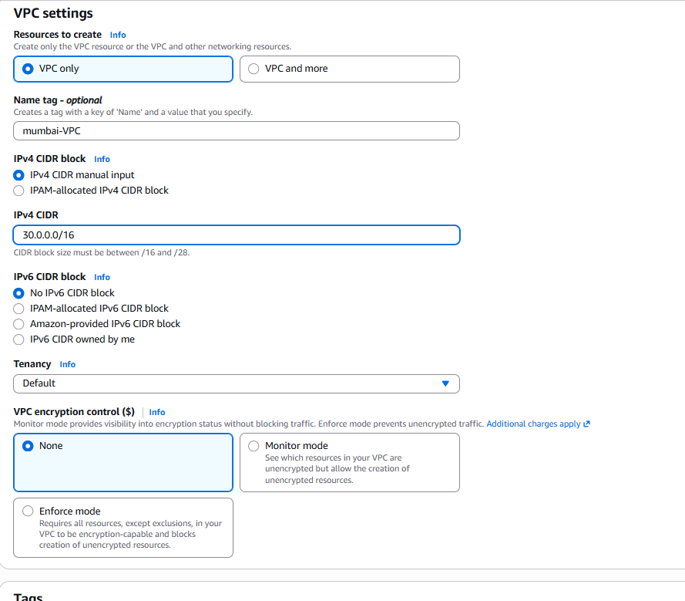
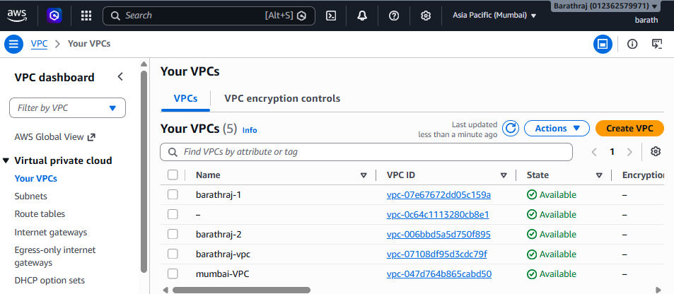

Step 6 — Create Mumbai Subnet
Navigate to:
VPC
→ Subnets
→ Create subnet
Configure:
Setting | Value
VPC | StudentName-Mumbai-VPC
Subnet name | StudentName-Mumbai-Subnet
Availability Zone | ap-south-1a
IPv4 CIDR | 30.0.2.0/24
Click:
Create subnet
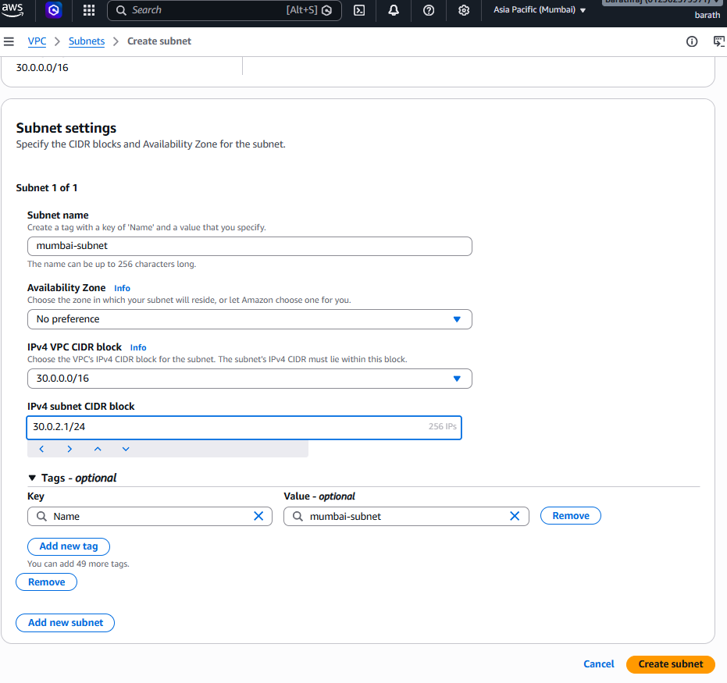

Step 7 — Create Mumbai Internet Gateway
Navigate to:
VPC
→ Internet Gateways
→ Create Internet Gateway
Name:
StudentName-Mumbai-IGW
Click:
Create Internet Gateway
Attach it:
Actions
→ Attach to VPC
→ StudentName-Mumbai-VPC
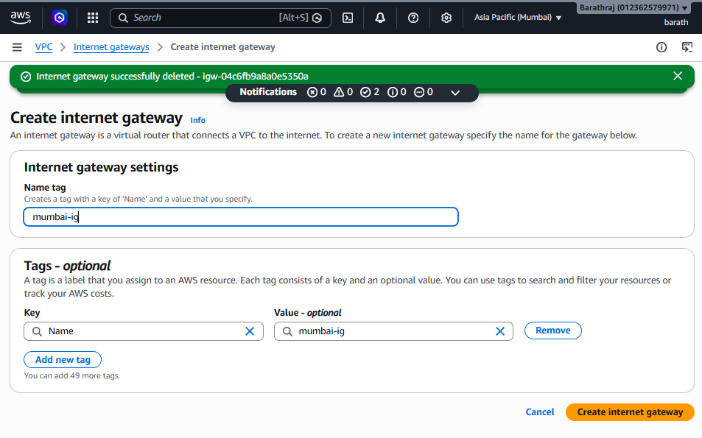
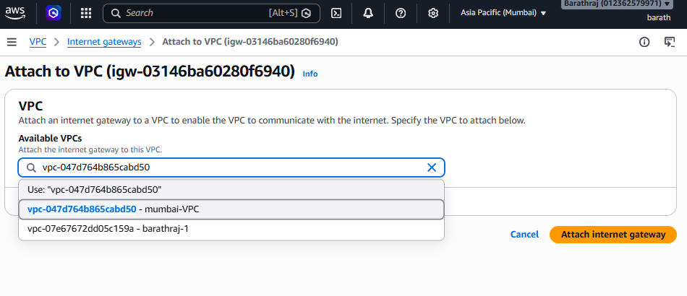

Step 8 — Create Mumbai Route Table
Navigate to:
VPC
→ Route Tables
→ Create Route Table
Configure:
Setting | Value
Name | StudentName-Mumbai-RT
VPC | StudentName-Mumbai-VPC
Create the route table.
Add the Internet route:
Destination | Target
0.0.0.0/0 | StudentName-Mumbai-IGW
Save the route.
Associate the route table with:
StudentName-Mumbai-Subnet
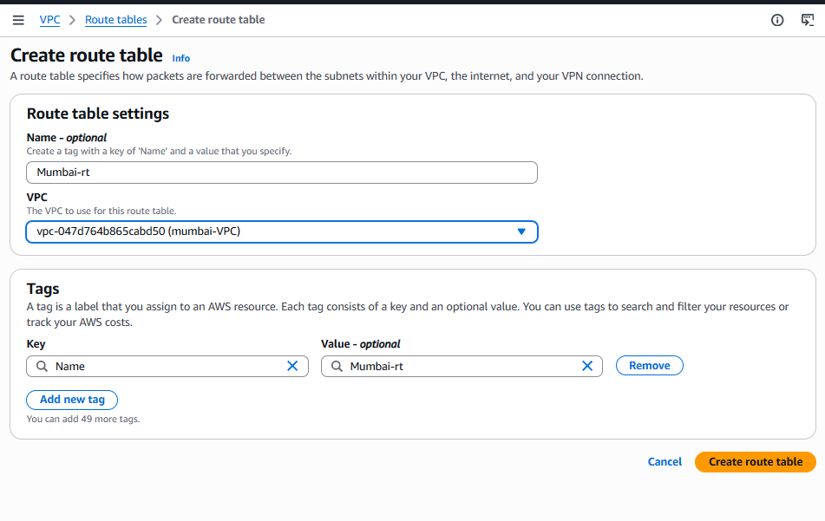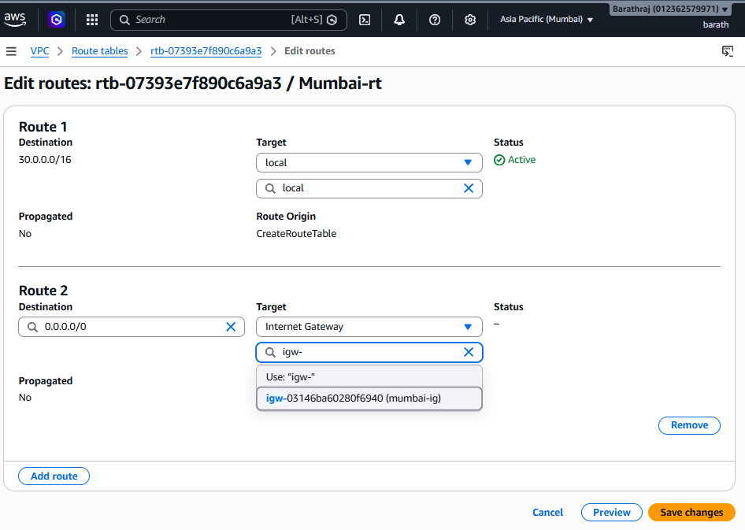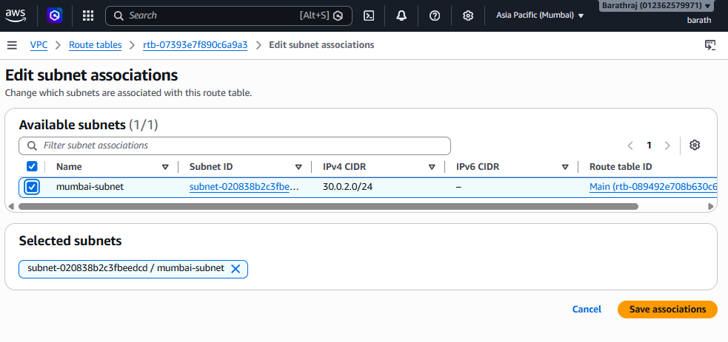

Step 9 — Launch Hyderabad EC2
Change the Region to:
Asia Pacific (Hyderabad)
ap-south-2
Navigate to:
EC2
→ Instances
→ Launch Instance
Configure:
Setting | Value
Name | StudentName-HYD-EC2
AMI | Amazon Linux 2023
Instance Type | t3.micro / available lab type
VPC | StudentName-HYD-VPC
Subnet | StudentName-HYD-Subnet
Auto-assign Public IP | Enable
Key Pair | Key pair for Hyderabad
Security Group
Create a Security Group:
StudentName-HYD-SG
Inbound rules:
Type | Port | Source
SSH | 22 | My IP
ICMP - IPv4 | — | 30.0.0.0/16
The ICMP rule is required if you want to test ping from the Mumbai VPC.
Launch the EC2 instance.
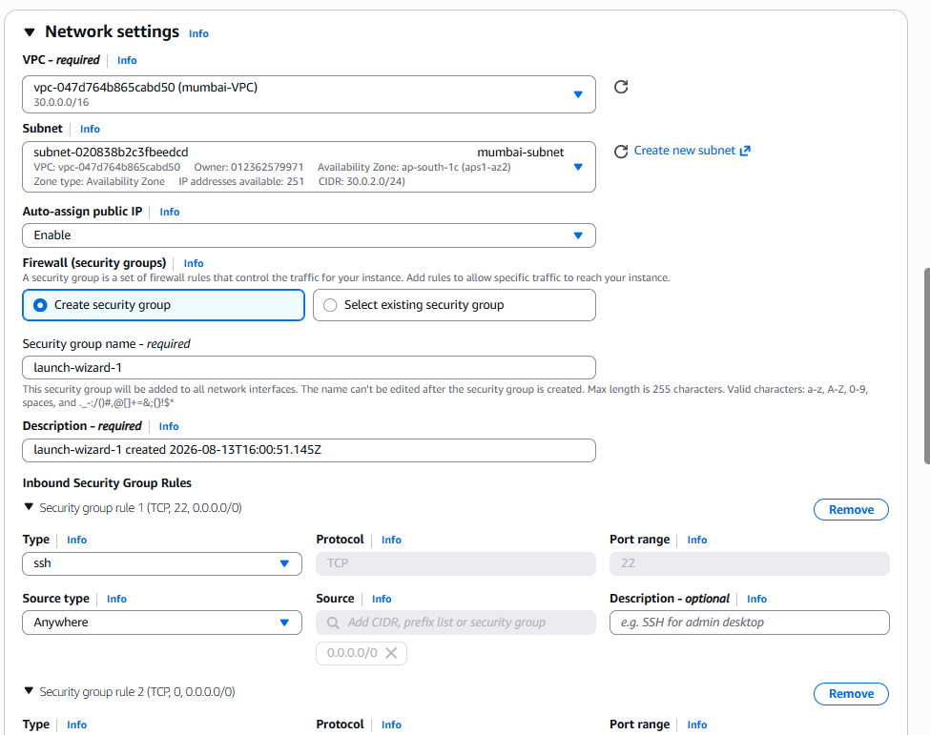
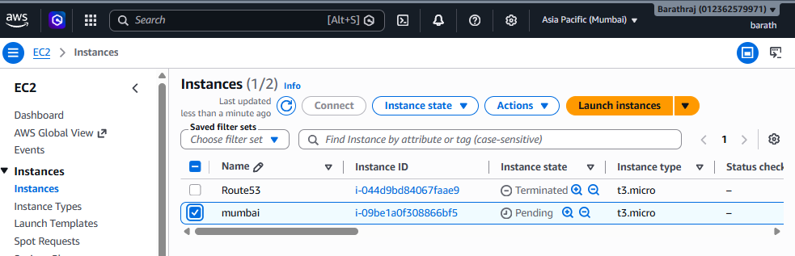

Step 10 — Launch Mumbai EC2
Change the Region to:
Asia Pacific (Mumbai)
ap-south-1
Navigate to:
EC2
→ Instances
→ Launch Instance
Configure:
Setting | Value
Name | StudentName-Mumbai-EC2
AMI | Amazon Linux 2023
Instance Type | t3.micro / available lab type
VPC | StudentName-Mumbai-VPC
Subnet | StudentName-Mumbai-Subnet
Auto-assign Public IP | Enable
Key Pair | Key pair for Mumbai
Create/select the Security Group:
StudentName-Mumbai-SG
Inbound rules:
Type | Port | Source
SSH | 22 | My IP
ICMP - IPv4 | — | 10.0.0.0/16
Launch the instance.
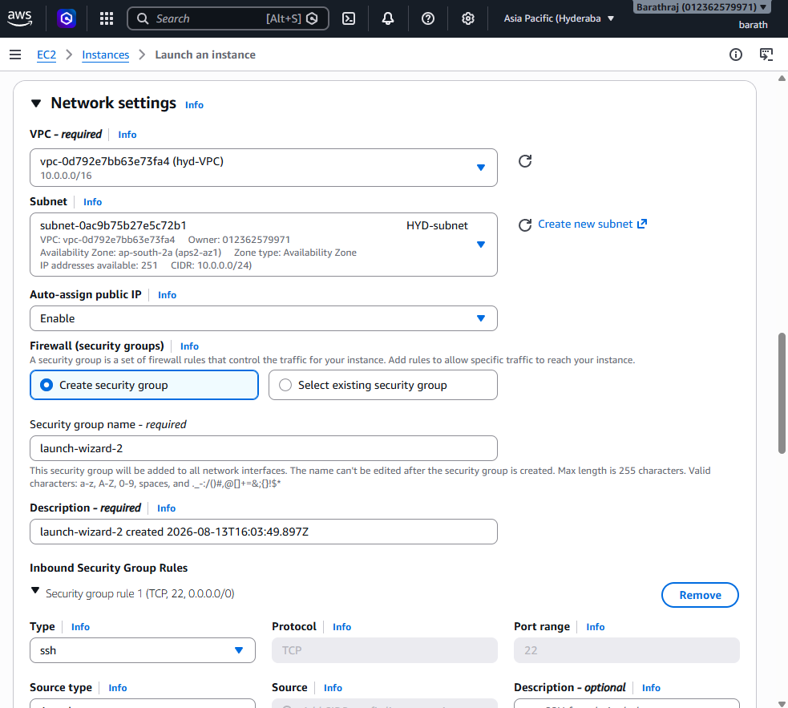
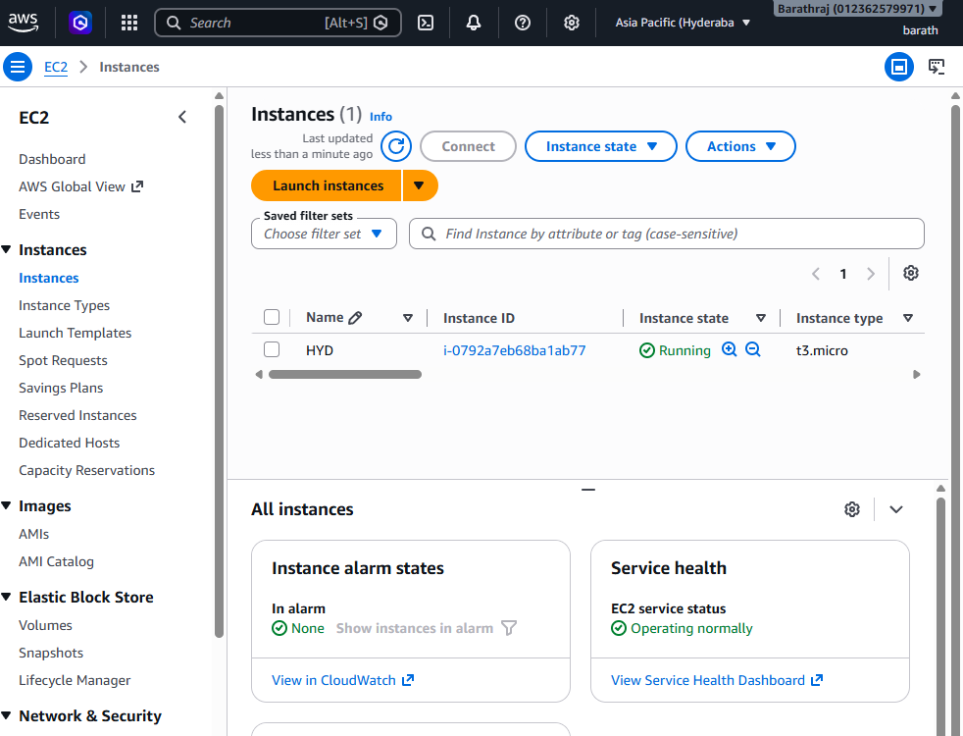

Step 11 — Get the VPC IDs
Now find the VPC ID of both VPCs.
Example:
Hyderabad VPC
CIDR: 10.0.0.0/16
VPC ID: vpc-xxxxxxxx
Mumbai VPC
CIDR: 30.0.0.0/16
VPC ID: vpc-yyyyyyyy
You need the Mumbai VPC ID while creating the peering request from Hyderabad.
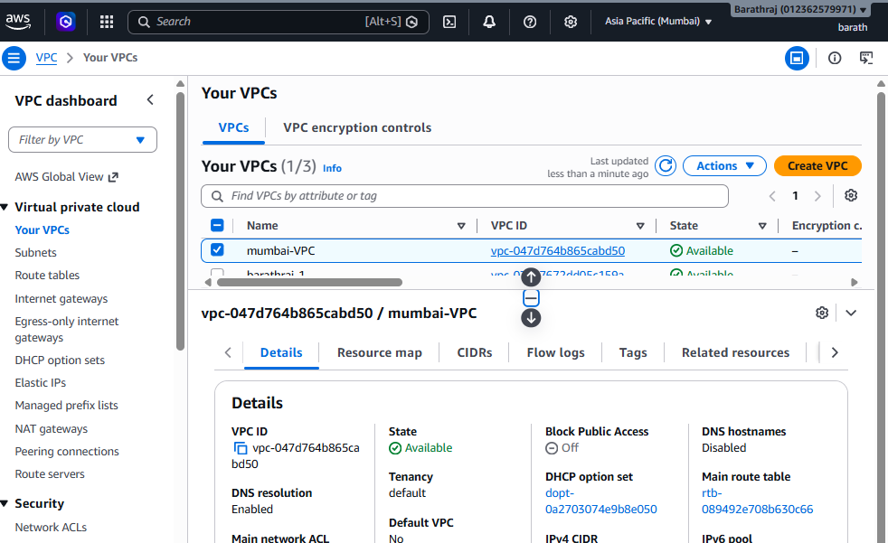

Step 12 — Create VPC Peering Connection
Change the Region to:
Hyderabad
ap-south-2
Navigate to:
VPC
→ Peering connections
→ Create peering connection
Configure:
Setting | Value
Name | StudentName-HYD-Mumbai-Peering
Requester VPC | StudentName-HYD-VPC
Account | My account
Region | Another Region
Region | Asia Pacific (Mumbai)
Accepter VPC ID | Mumbai VPC ID
Example:
Accepter VPC ID:
vpc-yyyyyyyy
Click:
Create peering connection
Initially, the status will be:
Pending Acceptance
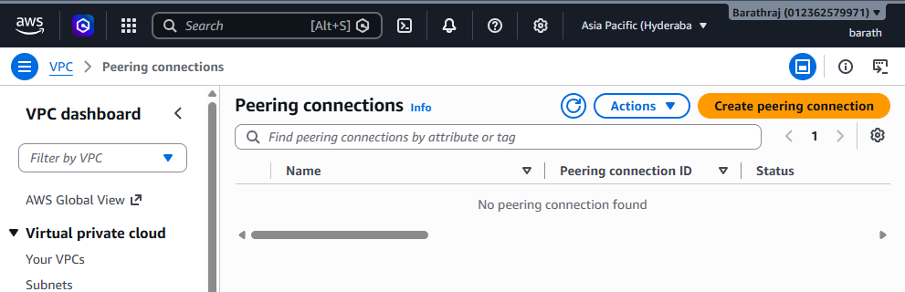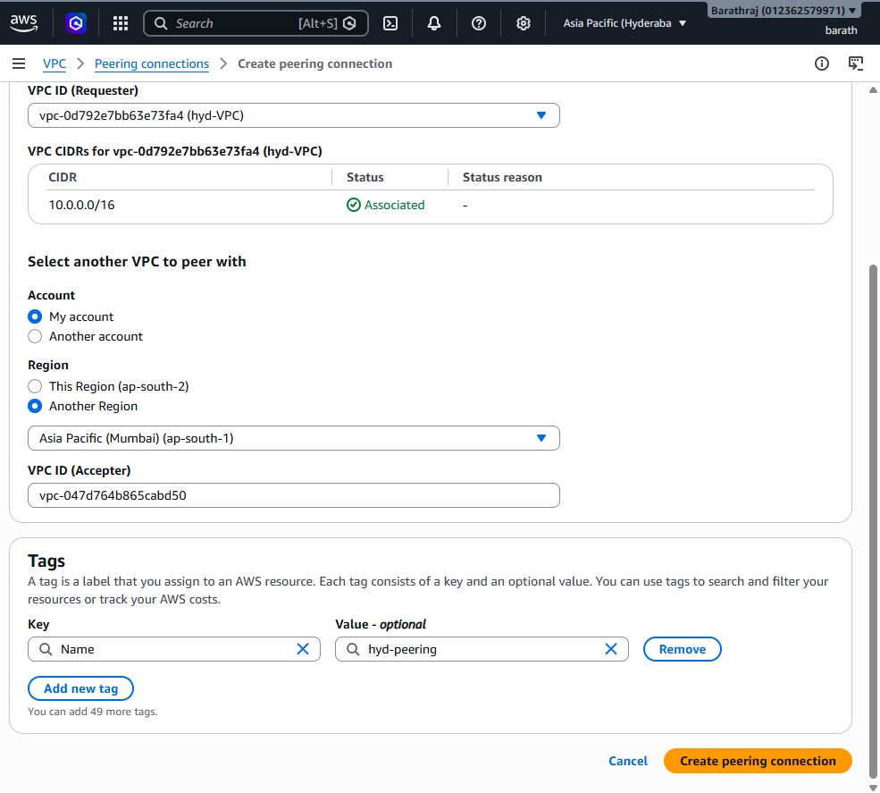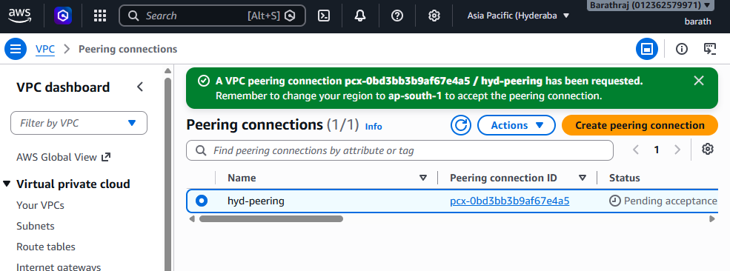

Step 13 — Accept the Peering Request
Change the AWS Region to:
Mumbai
ap-south-1
Navigate to:
VPC
→ Peering connections
You will see the peering request.
Select the request.
Go to:
Actions
→ Accept request
Confirm.
The status should now become:
Active
Now the Hyderabad VPC and Mumbai VPC have an active peering connection.
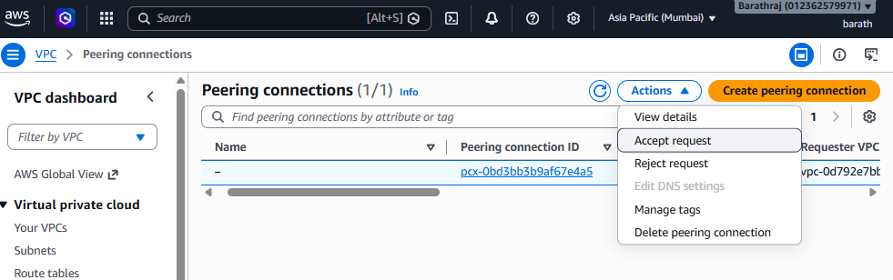

Extra:
Important — Peering Connection Alone Is Not Enough
Creating the VPC Peering connection does not automatically create routes.
You must add a route to the peer VPC CIDR in the route table on each side.
This is one of the most important concepts in VPC Peering.

For to access the private network:

Step 14 — Add Route in Hyderabad
Change to:
Hyderabad
ap-south-2
Navigate to:
VPC
→ Route Tables
→ StudentName-HYD-RT
→ Routes
→ Edit routes
→ Add route
Add:
Destination | Target
30.0.0.0/16 | VPC Peering Connection
Select:
pcx-xxxxxxxx
Save changes.
This means:
Traffic going to 30.0.0.0/16
↓
Send through VPC Peering
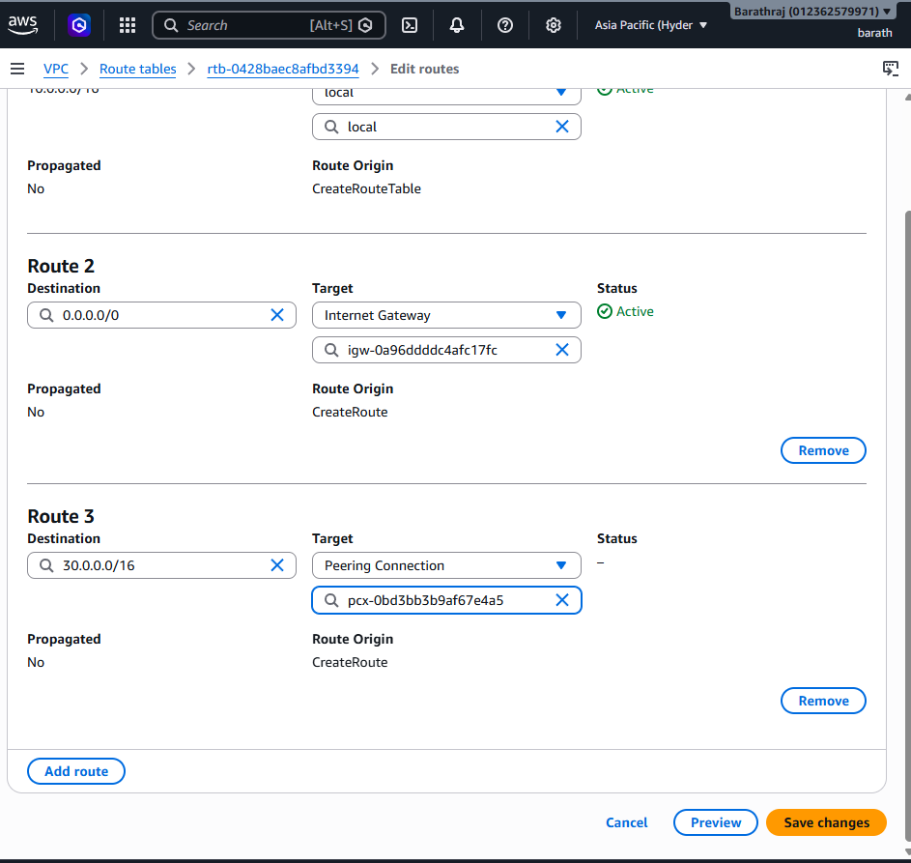

Step 15 — Add Route in Mumbai
Change to:
Mumbai
ap-south-1
Navigate to:
VPC
→ Route Tables
→ StudentName-Mumbai-RT
→ Routes
→ Edit routes
→ Add route
Add:
Destination | Target
10.0.0.0/16 | VPC Peering Connection
Select:
pcx-xxxxxxxx
Save changes.
This means:
Traffic going to 10.0.0.0/16
↓
Send through VPC Peering
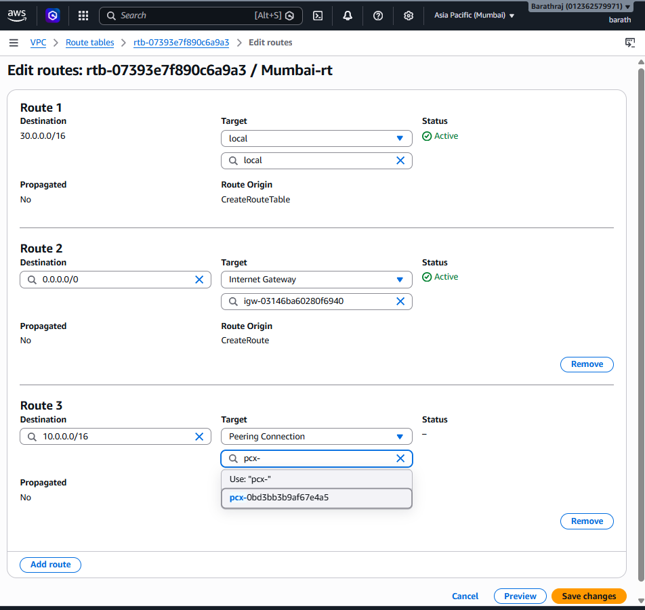

Final Route Tables
Hyderabad Route Table
Destination Target

10.0.0.0/16 local
30.0.0.0/16 VPC Peering Connection
0.0.0.0/0 Internet Gateway
Mumbai Route Table
Destination Target

30.0.0.0/16 local
10.0.0.0/16 VPC Peering Connection
0.0.0.0/0 Internet Gateway
Now both VPCs know how to reach each other.

Step 16 — Configure Security Groups
Routing is not the only requirement.
Security Groups must also allow the traffic.
Hyderabad Security Group
For Mumbai → Hyderabad communication:
SSH
TCP
22
Source: 30.0.0.0/16
For ping:
ICMP - IPv4
Source: 30.0.0.0/16
Mumbai Security Group
For Hyderabad → Mumbai communication:
SSH
TCP
22
Source: 10.0.0.0/16
For ping:
ICMP - IPv4
Source: 10.0.0.0/16

Step 17 — Connect to Hyderabad EC2
From your local computer:
ssh -i HYD-Key.pem ec2-user@<HYD-Public-IP>
Example:
ssh -i StudentName-HYD-Key.pem ec2-user@<HYD-Public-IP>

Step 18 — Test Communication Between VPCs
From the Hyderabad EC2, get the private IP of the Mumbai EC2.
Example:
Mumbai EC2 Private IP:
30.0.2.85
Run:
ping 30.0.2.85
If everything is correctly configured, you should receive responses:
64 bytes from 30.0.2.85
64 bytes from 30.0.2.85
64 bytes from 30.0.2.85
The traffic flow is:
HYD EC2
↓
HYD Route Table
↓
VPC Peering
↓
Mumbai Route Table
↓
Mumbai EC2
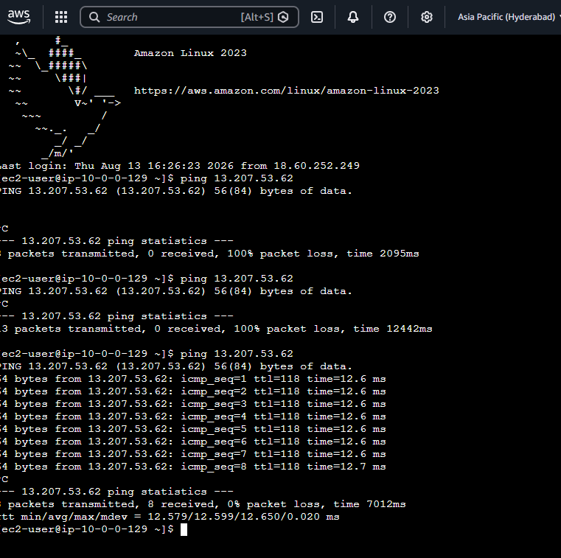

Step 19 — SSH Through VPC Peering
You can also SSH from one EC2 to the other using the private IP.
Example:
ssh -i Mumbai-Key.pem ec2-user@30.0.2.85
For this to work:
- Peering must be Active.
- HYD route table must contain the Mumbai VPC CIDR.
- Mumbai route table must contain the HYD VPC CIDR.
- Mumbai Security Group must allow TCP 22 from the HYD VPC CIDR.
- The correct private key must be available.
- NACLs must not block the traffic.
Important
The private key does not create the network connection.
The roles are:
Private Key
↓
SSH Authentication

Route Table
↓
Network Path

VPC Peering
↓
Connects VPCs

Security Group
↓
Allows/blocks traffic

How VPC Peering Traffic Works
Suppose:
HYD EC2 Private IP
10.0.0.10
and:
Mumbai EC2 Private IP
30.0.2.85
You run:
ping 30.0.2.85
The traffic flow is:
HYD EC2
↓
HYD Subnet
↓
HYD Route Table
↓
30.0.0.0/16 → VPC Peering
↓
VPC Peering Connection
↓
Mumbai Route Table
↓
Mumbai Subnet
↓
Mumbai EC2
The return traffic follows the reverse path.

Important VPC Peering Concepts
1. CIDR Blocks Must Not Overlap
Correct:
HYD VPC
10.0.0.0/16

Mumbai VPC
30.0.0.0/16
Incorrect:
HYD VPC
10.0.0.0/16

Mumbai VPC
10.0.0.0/16
The networks must have non-overlapping CIDR ranges.

2. VPC Peering Is Not Transitive
Suppose:
VPC A
|
| Peering
|
VPC B
|
| Peering
|
VPC C
VPC A cannot automatically communicate with VPC C through VPC B.
A → B → C
does not make B a transit network.
This is called:
No Transitive Routing

3. Routes Are Required on Both Sides
You need:
HYD Route Table:

30.0.0.0/16 → Peering
and:
Mumbai Route Table:

10.0.0.0/16 → Peering
If you configure only one side, communication will not work correctly.

4. Security Groups Still Apply
VPC Peering does not bypass Security Groups.
You need:
Route Table
+
Security Group
Both must allow the traffic.

5. NACL Still Applies
NACL also controls the traffic.
If your NACL blocks the required traffic, the communication will fail.
Remember:
VPC
↓
Route Table
↓
NACL
↓
Security Group
↓
EC2

6. VPC Peering Does Not Provide Internet Access
VPC Peering is used to connect:
VPC A
↓
VPC Peering
↓
VPC B
It is not a replacement for:
Internet Gateway
or:
NAT Gateway

7. Cross-Region VPC Peering
Your lab uses:
Hyderabad
ap-south-2
↓
VPC Peering
↓
Mumbai
ap-south-1
This is called:
Inter-Region VPC Peering

8. Private IP Communication
For testing VPC Peering, use the private IP of the peer EC2.
Example:
ping 30.0.2.85
The important network path is:
Private IP
↓
Route Table
↓
VPC Peering
↓
Private IP

9. Public IP vs Private IP
An EC2 can have:
Private IP
+
Public IP
Example:
Private IP:
30.0.2.85

Public IP:
13.xxx.xxx.xxx
For demonstrating VPC Peering, focus on communication using the private IP.

VPC Peering vs Internet Gateway
Internet Gateway | VPC Peering
Connects VPC to Internet | Connects VPC to another VPC
Used for internet connectivity | Used for VPC-to-VPC communication
Common route: 0.0.0.0/0 | Route uses peer VPC CIDR
Target is IGW | Target is PCX
Internet communication | Private network communication

VPC Peering vs NAT Gateway
VPC Peering | NAT Gateway
Connects two VPCs | Provides outbound internet access
VPC-to-VPC | Private subnet-to-internet
Target is PCX | Target is NAT Gateway
Uses peer VPC CIDR | Usually 0.0.0.0/0
Private communication | Outbound internet access

VPC Peering vs Transit Gateway
VPC Peering
VPC A
|
| Peering
|
VPC B
Best for a small number of direct VPC connections.
Transit Gateway
Transit Gateway
/ | \
/ | \
VPC A VPC B VPC C
Transit Gateway is useful when connecting many VPCs and networks.

Troubleshooting VPC Peering
If:
ping <Mumbai-Private-IP>
doesn't work, check the following.
Check 1 — Peering Status
Make sure:
Status: Active

Check 2 — CIDR
Make sure the CIDRs don't overlap.
Example:
HYD:
10.0.0.0/16

Mumbai:
30.0.0.0/16

Check 3 — Hyderabad Route
Check:
30.0.0.0/16 → VPC Peering

Check 4 — Mumbai Route
Check:
10.0.0.0/16 → VPC Peering

Check 5 — Security Group
Check that ICMP or SSH is allowed from the peer VPC CIDR.

Check 6 — NACL
Check inbound and outbound NACL rules.

Check 7 — EC2
Make sure both EC2 instances are:
Running

Check 8 — Test Private IP
Use:
ping <peer-private-ip>
rather than relying only on the public IP.

Verification Checklist
Verification | Expected Result
Hyderabad VPC created | ✅ Yes
Mumbai VPC created | ✅ Yes
CIDRs don't overlap | ✅ Yes
Hyderabad subnet created | ✅ Yes
Mumbai subnet created | ✅ Yes
Hyderabad IGW attached | ✅ Yes
Mumbai IGW attached | ✅ Yes
Hyderabad route table created | ✅ Yes
Mumbai route table created | ✅ Yes
Hyderabad EC2 created | ✅ Yes
Mumbai EC2 created | ✅ Yes
Peering request created | ✅ Yes
Peering request accepted | ✅ Yes
Peering status | Active
HYD route to Mumbai CIDR | ✅ Yes
Mumbai route to HYD CIDR | ✅ Yes
Security Groups configured | ✅ Yes
Private IP ping | ✅ Yes
Private IP SSH | ✅ If SSH is allowed

Reverse Process — Cleanup
After completing the lab, delete the resources.
Step 1 — Terminate EC2 Instances
Go to:
EC2
→ Instances
Terminate:
StudentName-HYD-EC2
StudentName-Mumbai-EC2

Step 2 — Delete VPC Peering
Go to:
VPC
→ Peering connections
Select:
StudentName-HYD-Mumbai-Peering
Then:
Actions
→ Delete peering connection

Step 3 — Delete Route Tables
Delete:
StudentName-HYD-RT
StudentName-Mumbai-RT

Step 4 — Detach Internet Gateways
For Hyderabad:
HYD-IGW
→ Actions
→ Detach from VPC
For Mumbai:
Mumbai-IGW
→ Actions
→ Detach from VPC
Then delete the Internet Gateways.

Step 5 — Delete Subnets
Delete:
StudentName-HYD-Subnet
StudentName-Mumbai-Subnet

Step 6 — Delete VPCs
Finally delete:
StudentName-HYD-VPC
StudentName-Mumbai-VPC

What You Practiced
Skill | Description
VPC creation | Created isolated networks
Subnet | Created network segments
Internet Gateway | Provided internet connectivity
Route Table | Controlled traffic paths
Security Group | Controlled EC2 traffic
EC2 | Created servers in both Regions
VPC Peering | Connected two VPCs
Cross-Region Networking | Connected Hyderabad and Mumbai
Private IP Communication | Communicated between VPCs
Routing | Added routes for peer VPC CIDRs
Troubleshooting | Checked routes and security

AWS VPC Peering Interview Questions
1. What is VPC Peering?
Answer:
VPC Peering is a network connection between two VPCs that allows resources in those VPCs to communicate with each other.

2. Can VPC Peering work between different Regions?
Answer:
Yes. AWS supports cross-region VPC Peering.

3. Can two VPCs with overlapping CIDRs be peered?
Answer:
No. The VPC CIDR blocks must not overlap.

4. Does creating VPC Peering automatically create routes?
Answer:
No. We must manually add routes to the peer VPC CIDR in the appropriate route tables.

5. What is the target used in a VPC Peering route?
Answer:
The VPC Peering Connection, identified by a pcx-xxxx ID.
Example:
30.0.0.0/16 → pcx-xxxxxxxx

6. Is VPC Peering transitive?
Answer:
No. VPC Peering does not support transitive routing.

7. Does VPC Peering use the public internet?
Answer:
VPC Peering provides private communication between the VPCs. It is not an internet gateway or NAT service.

8. Do Security Groups work with VPC Peering?
Answer:
Yes. Security Groups continue to control traffic to and from EC2 instances.

9. Do NACLs work with VPC Peering?
Answer:
Yes. NACL rules still apply to traffic entering and leaving the subnet.

10. What happens if the peering status is Active but communication doesn't work?
Answer:
Check:
- Route tables.
- Security Groups.
- NACLs.
- CIDR ranges.
- EC2 status.
- Correct private IP.

11. What is the difference between VPC Peering and NAT Gateway?
Answer:
VPC Peering connects two VPCs, while NAT Gateway allows private subnet resources to access the internet for outbound traffic.

12. What is the difference between VPC Peering and Transit Gateway?
Answer:
VPC Peering is mainly a direct point-to-point connection, while Transit Gateway acts as a central network hub for connecting multiple VPCs and other networks.

⭐ 5 Things You Must Remember
1. VPC Peering = Connect two VPCs.

2. CIDRs must NOT overlap.

3. Creating peering alone is NOT enough.

4. Add routes on BOTH VPCs.

5. VPC Peering is NOT transitive.

Final Traffic Flow
Hyderabad VPC
10.0.0.0/16
|
|
HYD EC2
|
↓
HYD Route Table
|
30.0.0.0/16 → PCX
|
↓
VPC PEERING
pcx-xxxx
|
↓
Mumbai Route Table
|
30.0.0.0/16 → Local
|
↓
Mumbai EC2
30.0.2.0/24
The Core Concept
VPC A
10.0.0.0/16
|
| 30.0.0.0/16 → PCX
|
↓
VPC PEERING
↑
|
| 10.0.0.0/16 → PCX
|
VPC B
30.0.0.0/16
Remember:
Peering connects the VPCs, Route Tables tell the traffic where to go, Security Groups/NACLs control whether the traffic is allowed, and the EC2 private IP is used for private communication.

